Ergonomics at VDU workstations

VDU work does not put an excessively high strain on your health. Because of the long hours employees normally spend at VDU workstations, however, certain pointers should be taken on board to avoid complaints and feel at ease. These concern both the organisation of the workstation and personal physical behaviour. The following pointers should enable you to optimise your workstation to suit your needs and incorporate movement into your daily routine.

Chair and table height
- Sit right back on your chair.
- Set the height of your chair so that your forearms rest on the table top when you relax your shoulders and your upper and forearms are at right angles to each other.
- If the angle in the knee area deviates significantly from a right angle (feet flat on the floor), check whether you can order a lower or higher chair. The tables (table legs) at ETH Zurich are available in the heights 70, 74 and 78 cm.
- If you are no longer in contact with the floor, a foot rest should be used.

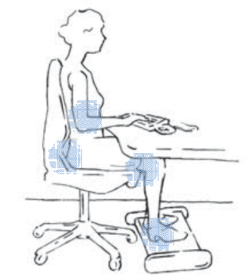
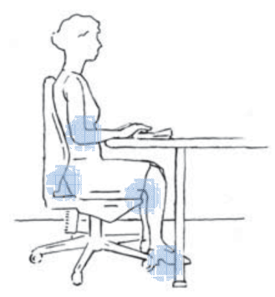

Adjusting the chair
- Adjust the backrest so that the curvature is positioned at waist height.
- Adjust the seat depth: if you sit right back on the chair, a space two fingers wide should remain between the edge of the chair and the backs of the knees.
- Adjust the backrest to facilitate dynamic sitting (moving backrest), adjusting the spring action of the backrest to suit the body weight. Change your posture frequently. Sit up straight, sometimes leaning forward, sometimes back.
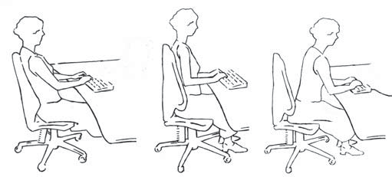

Space conditions
- Enough space for the legs (no clutter, table legs, wastepaper basket under the table).

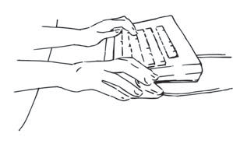
Keyboard
Position keyboard in such a way that:
- It lies flat on the table (don’t open out the “feet”)
- It lies parallel to the table’s edge
- It lies at least 10 cm away from the table’s edge
- You can rest your forearms on the table

Mouse
- Position the mouse directly next to the keyboard
- Move the mouse with your forearm instead of the wrist
- Avoid having to spread the shoulders because the mouse has been placed too far away
- Grip the mouse very loosely
- Avoid frequent double clicks

Monitor
- Set up monitor so that the light hits it from the side while working (shoulders towards the window) to avoid glare from the window and reflections on the monitor
- Do not position the monitor directly under overhead lights, but rather between them
- Place the monitor directly in front of you to avoid having to keep turning your head or upper body
- Make sure the distance from the eyes to the monitor is 50 to 90 cm
- Set up the monitor so that the upper rim of the screen is below eye level

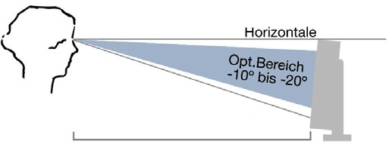
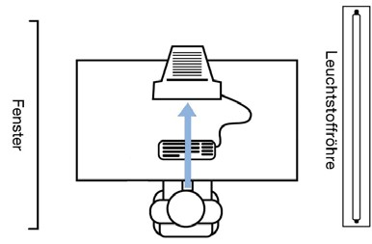

Movement
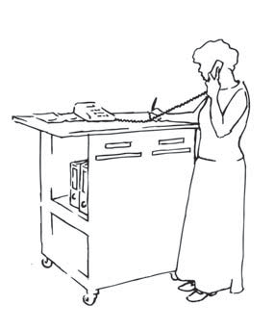
There is no “correct” work posture for you to adopt the whole day. We therefore recommend you take several short breaks during the working day and vary your work posture regularly.
- For a change, perform tasks standing up (e.g. making telephone calls or reading files)
- Arrange your workstation in such a way that you have to get up to fetch documents from the printer or a glass of water
- Consciously take short breaks to relax mentally and physically; you can achieve this via stretching and relaxation exercises, for instance. Remember: it is more relaxing to take short breaks at short intervals than longer breaks at longer intervals

